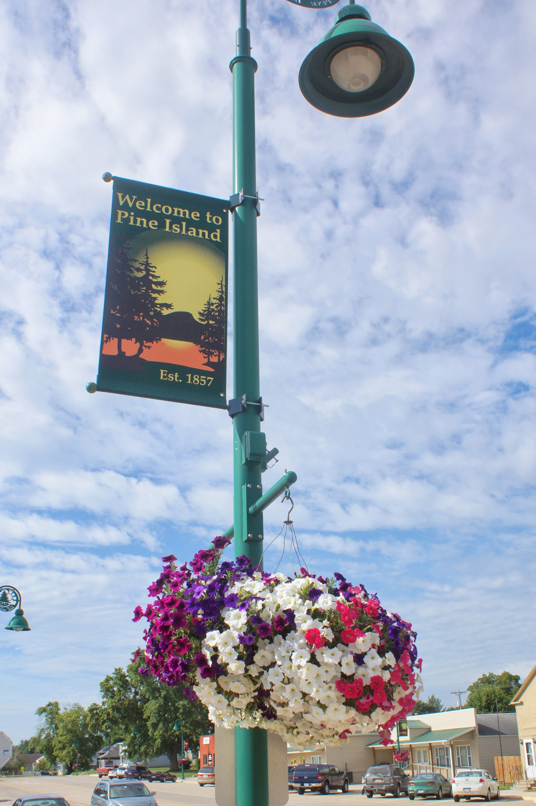
Main Street Flower Baskets
2026 Donation Form

The Pine Island Area Chamber of Commerce is again pleased to coordinate the purchase of hanging flower baskets to add color and beauty to Main Street. Our thanks to the City of Pine Island as they continue to care for the flower baskets to keep them growing throughout the season.

Please consider making a donation to purchase a basket. The flowers add to the attractiveness of Main Street for many months throughout the summer and fall. Without the support of our Chamber members as well as the community, projects like this would not be possible.

Please make checks payable to Pine Island Area Chamber of Commerce and mail
along with the bottom portion of this form to:
P.O. Box 441 Pine Island MN 55963

If you have any questions, contact us at piareachamber@gmail.com or 507-356-8233. Thank you for your generous donation to beautify our community!

Business or Individual’s Name: ___________________________________________

I would like to sponsor _____ baskets at $60.00 each.

Total enclosed: _______



